

AMERICAN INTERNATIONAL UNIVERSITY–BANGLADESH (AIUB)
Dept. of Computer Science
Faculty of Science and Technology
CSC2210: OBJECT ORIENTED PROGRAMMING 2
Summer 2025-2026
Section: [X]
Group No: 0012

Project Report On
Super Store Management System
Supervised By
DR. MD. IFTEKHARUL MOBIN

Submitted By:
Name | ID
1. ROMIT BARMAN TOZO | 23-54566-3
2. SADMAN ISLAM SHIFAT | 24-56183-3
Obtained Marks for CO2 and CO3 (Description given in the following page)
Assessment  Criteria | Not Attended/ Incorrect (0) |  | Inadequate  (1-2) |  | Average  (3) | Good  (4) | Excellent  (5)
Evaluation Criteria (CO2) |  | Total = |  | Evaluation Criteria (CO3) |  |  | Total =
Requirement fulfillment |  |  |  | Organization of the application
Validation |  |  |  | Representation and Integration of Database
Verification |  |  |  | Graphical User Interface

CO2: Display and verify the mean of a real-life Project using the concepts of C# Graphical User Interface based environment with database integration to depict a desktop-based application.
Assessment  Criteria | Not Attended/ Incorrect (0) | Inadequate  (1-2) |  | Average  (3) |  | Good  (4) |  | Excellent  (5)
Evaluation Criteria | Evaluation Definition
Requirement fulfillment | Fails to demonstrate any understanding of real-life scenario-based project development or functional requirement identification. There is no attempt to depict a project or identify functional requirements accurately. |  | Demonstrates limited understanding of real-life scenario-based project development and functional requirement identification. The project depicted lacks coherence or relevance to real-life scenarios, and functional requirements are inaccurately identified or insufficiently described. |  | Presents a basic depiction of a real-life scenario-based project and identifies some functional requirements. However, the project lacks depth or complexity, and some functional requirements may be vaguely defined or missing key details. |  | Effectively demonstrates a realistic scenario-based project and accurately identifies most functional requirements. The project is well-developed with appropriate complexity, and functional requirements are clearly articulated with relevant details. |  | Exhibits an exceptional understanding of real-life scenario-based project development and accurately identifies all functional requirements. The project is meticulously developed with thorough attention to detail, reflecting a comprehensive understanding of Object-Oriented Programming project development activities.
Validation | Fails to demonstrate any understanding or implementation of validation forms in their system. There is no attempt to deal with data validation, and validation requirements are completely ignored or incorrectly applied. |  | Demonstrates limited understanding of validation forms and data validation techniques. While some attempt may be made to implement validation, it is incomplete or poorly executed, leading to inadequate handling of data validation. |  | Shows a basic understanding of validation forms and data validation techniques. They attempt to implement validation, but some aspects may be missing or incorrectly implemented, resulting in partial or inconsistent handling of data validation. |  | Effectively demonstrates the use of validation forms and implements data validation techniques. Validation is mostly accurate and comprehensive, ensuring the proper handling of data input and verification in the system. |  | Exhibits an exceptional understanding and implementation of validation forms and data validation techniques. Validation is meticulously implemented with thorough attention to detail, ensuring robust data validation procedures and contributing to the overall reliability and integrity of the system.
Verification | Fails to demonstrate any attempt to verify the system data or functional requirements. There is no evidence of understanding or implementation of verification processes, and data flow is not considered. |  | Demonstrates limited understanding of verification processes and data flow in the system. Verification attempts are incomplete or inaccurate, and there is insufficient consideration given to ensuring data integrity and functionality. |  | Shows a basic understanding of verification processes and attempts to verify system data. However, verification efforts may be inconsistent or lack thoroughness, and there may be gaps in ensuring proper functional requirements and data flow. |  | Identifies and verifies system data, ensuring proper functional requirements are met. Verification efforts are mostly accurate and thorough, with attention to ensuring data integrity and appropriate data flow within the system. |  | Exhibits an exceptional understanding of verification processes and meticulously verifies system data. Verification efforts are comprehensive and precise, with a keen focus on ensuring all functional requirements are met and maintaining proper data flow throughout the system.

CO3: Prepare and Explain a real life desktop based application synthesizing several component of C# along with development tools to adhere the given requirements.
Assessment  Criteria | Not Attended/ Incorrect (0) | Inadequate  (1-2) |  | Average  (3) |  | Good  (4) |  | Excellent  (5)
Evaluation Criteria | Evaluation Definition
Organization of the application | Fails to identify any suitable real time application or requirements for project development activities related to OOP. |  | Limited understanding about the project scopes and scenarios or identification of functional requirements. |  | Lacks depth or relevance to OOP project development activities and may contain inaccuracies. Real-life scenarios are mentioned, but the discussion lacks depth or clarity. |  | Consider and integrate the idea of several core aspects of the project along with relevance to real-life scenarios. Demonstrating a solid understanding of the application presentation. |  | Generalize and exhibits an exceptional understanding of project preparation according to a to real-life scenarios. Also contains proper and insightful identification of the system which is comprehensive and precise.
Representation and Integration of Database | Fails to identify and present any understanding or implementation of database. Also failed to integrate the data with the project itself. |  | Limited understanding of the database concepts or their proper way of using in a real time project. While some attempt may be made to implement but it is incomplete or poorly executed, leading to inadequate design. |  | Lacks depth or relevance to database integration with the application. Shows a basic understanding but some aspects may be missing or incorrectly implemented, resulting in partial or inconsistency. May lack proper normalization. |  | Integrate the database with the forms properly and implements it with proper validation which is mostly accurate and comprehensive, ensuring the proper handling of data input and verification along with general normalization. |  | Exhibits an exceptional understanding and implementation of database ensuring attention to detail, and robust data manipulation procedures and contributing to the overall clarity.
Graphical User Interface | Fails to present or prepare GUI based application interfaces. There is no evidence of creating or integrating such things according to their usefulness. |  | Limited understanding of graphical user interfaces. Lack of design knowledge. Very poor attempt to make such things which are currently obsolete or can’t be identified as coherent. |  | Shows a basic understanding of creating user interfaces. Most of them are interconnected but maybe some of them lack it. However, most of it can be described as user friendly. |  | Effectively identifies and meet the consider the simplicity. Design related works are mostly accurate and taken proper attention to ensuring a user-friendly coherent system. |  | Exhibits an exceptional work design following a high standard of simple and elegant work. Several controls and mechanism has been organized in a preferred way according to the coherent usage .

Table of Contents: Page no.

1. Chapter :01 (Introduction)---------------------------------------------------------------------- 03
2. Chapter :02(User Story)------------------------------------------------------------------------- 03
3. Chapter :03 (ER Diagram)---------------------------------------------------------------------- 05
4. Chapter :03 (SQL Queries)--------------------------------------------------------------------- 06
5. Chapter:04 (Screenshots) ---------------------------------------------------------------------- 09

Case Study: Super Store Management System

The Super Store Management System serves as a comprehensive technological framework designed to streamline the diverse and high-volume operations of a modern large scale retail environment. Unlike smaller specialized shops, a super store must manage thousands of products across various departments such as groceries, household goods and electronics. The system is engineered to integrate inventory management, customer transactions and administrative oversight into a single cohesive platform. That ensures that the store operates with high precision and minimal manual error.
At the core of the system is a robust administrative module that allows for the meticulous management of the store’s vast inventory. Administrators have the authority to add new products, update existing pricing and modify essential details like brand names or expiration dates. To maintain organization within such a large catalog, the system utilizes an auto-generation feature for unique product IDs. This automation is critical in a super store setting because it prevents the duplication of stock records and ensures that every item is easily traceable. Furthermore, the system provides real-time stock updates, which means that as items are sold or restocked, the database reflects these changes instantly. This functionality allows administrators to perform quick product searches and generate reports to identify which items are running low, thereby preventing stockouts.
The customer side of the system is designed to optimize the shopping experience through an intuitive digital interface. Users can browse through various categories, add multiple items to a virtual shopping cart, and manage their selections with ease. The system automatically calculates the total cost, including any applicable taxes or discounts, providing transparency before the customer reaches the final checkout stage. This cart management feature is essential for handling the large-scale purchases typical of a super store, as it allows customers to remove unwanted items and reverify their totals in real time, ensuring a smooth transition to the payment process.
Security and data integrity are prioritized throughout the transaction and user management phases. When a payment is confirmed, the system executes complex SQL queries to simultaneously log the sale and reduce the corresponding stock levels in the database. This synchronized update ensures that the inventory counts remain accurate across all store departments. The payment process itself is protected by secure handling mechanisms and confirmation dialogs to prevent unauthorized transactions or data loss. Additionally, the system includes a hierarchical user management module where administrators can assign specific roles and permissions to employees. By controlling who can modify prices or access financial records, the system maintains a high level of operational security and accountability.
In conclusion, the Super Store Management System demonstrates the effective application of automation and database management in a retail context. By combining real time inventory tracking, seamless customer cart functionality and secure administrative controls, the system enhances both operational efficiency and customer satisfaction. It represents a vital tool for any scale retail business looking to minimize human error and manage a complex array of products and transactions with ease.

FUNCTIONALITIES:
### 1. User Login & Role-Based Access
* Customer login * Salesman login * Admin login * Super Admin login
* Different dashboard for each role
### 2. Customer Functionalities
* Browse products * View product details * Add products to cart * Update cart quantity
* Remove items from cart * Place order * View order history * Track delivery status
* Mark order as received * Submit product review * Give product rating from 1 to 5
* View previous reviews
### 3. Salesman Functionalities
* Browse products * Add products to cart for customer * Create customer bill/order
* Apply active discounts during checkout * View handled orders * Track delivery status
* Mark order as delivered
### 4. Admin Functionalities
* Add new products * Update product information * Delete/remove products
* Manage product stock * View bills/orders * Update delivery status
* Manage customer orders
### 5. Super Admin Functionalities
* Manage users * Add users * Update users * Remove users * Control user roles
### 6. Billing & Checkout
* Generate bills * Add bill items * Calculate total amount * Apply discount offers
* Calculate final amount * Update stock after checkout * Clear cart after order
### 7. Product Management
* Product name * Category * Brand * Model * Price * Stock quantity * Minimum stock
* Description
### 8. Review & Rating System
* Customers can submit reviews * Customers can give ratings
* Average rating shown in product list * All users can view product reviews
### 9. Discount Offer System
* Product-level discount offers * Start date and end date for offers
* Active offers applied automatically at checkout
* Highest active discount applied per product
### 10. Delivery Status Tracking
* Pending * Processing * Shipped * Delivered * Admin can update status
* Customer can track order * Salesman can track handled orders
### 11. Database & Setup
* SQL Server / LocalDB support
* Auto database initialization
* Sample data creation
* dbconfig.json connection support
* Environment variable fallback
* Auto setup using AUTO_SETUP.bat

Database Schema:

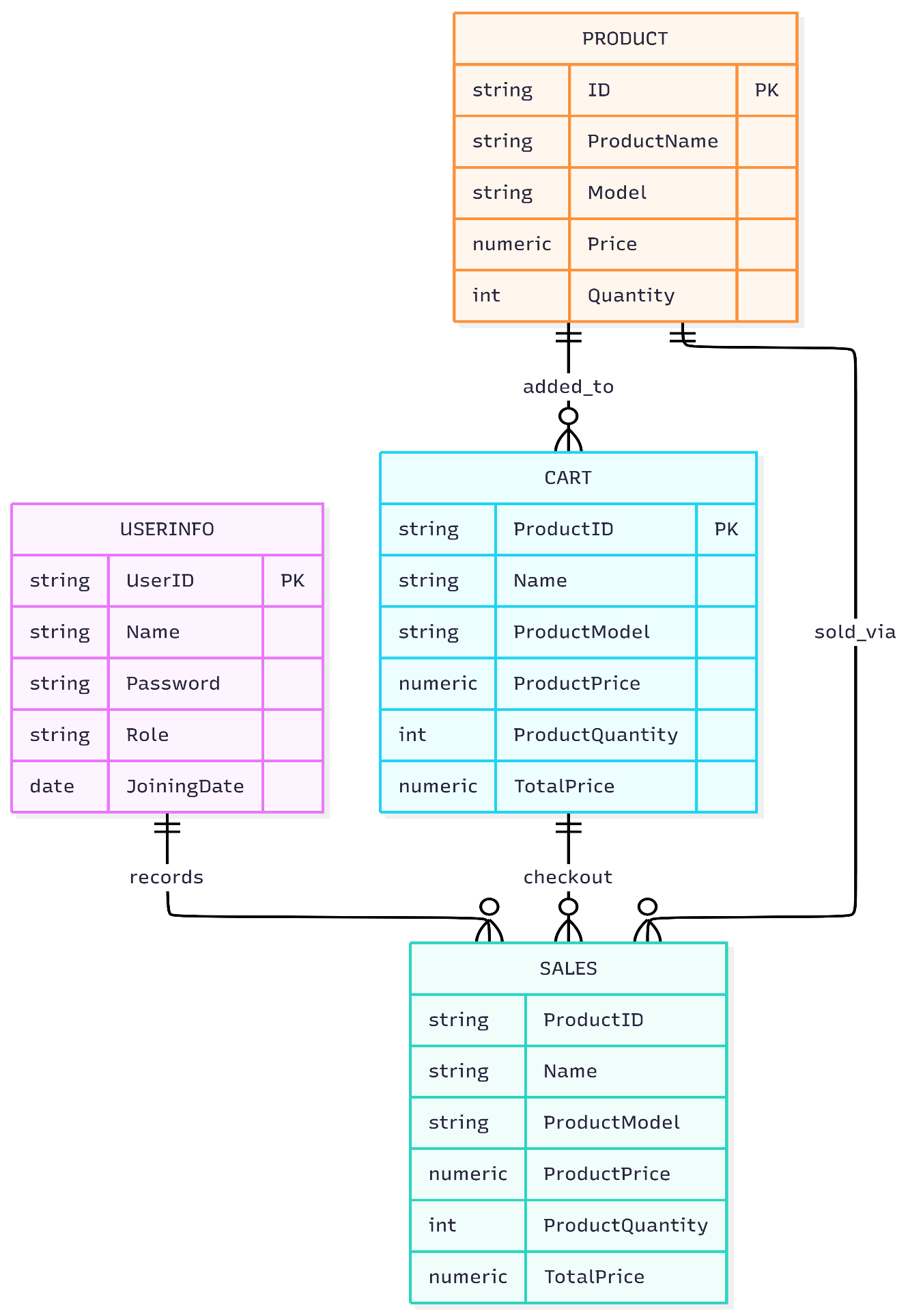

SQL:
USE [OOP2DB]
GO

/****** Object: Table [dbo].[UserInfo] Script Date: 14-May-26 15:40:00 ******/
SET ANSI_NULLS ON
GO
SET QUOTED_IDENTIFIER ON
GO
CREATE TABLE [dbo].[UserInfo](
[UserID] [nvarchar](10) NOT NULL,
[Name] [nvarchar](50) NULL,
[Password] [nvarchar](10) NULL,
[Role] [nvarchar](10) NULL,
[JoiningDate] [date] NULL,
CONSTRAINT [PK_UserInfo] PRIMARY KEY CLUSTERED
(
[UserID] ASC
)WITH (PAD_INDEX = OFF, STATISTICS_NORECOMPUTE = OFF, IGNORE_DUP_KEY = OFF, ALLOW_ROW_LOCKS = ON, ALLOW_PAGE_LOCKS = ON, OPTIMIZE_FOR_SEQUENTIAL_KEY = OFF) ON [PRIMARY]
) ON [PRIMARY]
GO

/****** Object: Table [dbo].[Product] Script Date: 14-May-26 15:40:00 ******/
SET ANSI_NULLS ON
GO
SET QUOTED_IDENTIFIER ON
GO
CREATE TABLE [dbo].[Product](
[ID] [nvarchar](10) NOT NULL,
[ProductName] [nvarchar](50) NULL,
[Model] [nvarchar](50) NULL,
[Price] [numeric](18, 0) NULL,
[Quantity] [int] NULL,
CONSTRAINT [PK_Product] PRIMARY KEY CLUSTERED
(
[ID] ASC
)WITH (PAD_INDEX = OFF, STATISTICS_NORECOMPUTE = OFF, IGNORE_DUP_KEY = OFF, ALLOW_ROW_LOCKS = ON, ALLOW_PAGE_LOCKS = ON, OPTIMIZE_FOR_SEQUENTIAL_KEY = OFF) ON [PRIMARY]
) ON [PRIMARY]
GO

/****** Object: Table [dbo].[Cart] Script Date: 14-May-26 15:40:00 ******/
SET ANSI_NULLS ON
GO
SET QUOTED_IDENTIFIER ON
GO
CREATE TABLE [dbo].[Cart](
[ProductID] [nvarchar](10) NOT NULL,
[Name] [nvarchar](50) NULL,
[ProductModel] [nvarchar](50) NULL,
[ProductPrice] [numeric](18, 0) NULL,
[ProductQuantity] [int] NULL,
[TotalPrice] [numeric](18, 0) NULL,
CONSTRAINT [PK_Cart] PRIMARY KEY CLUSTERED
(
[ProductID] ASC
)WITH (PAD_INDEX = OFF, STATISTICS_NORECOMPUTE = OFF, IGNORE_DUP_KEY = OFF, ALLOW_ROW_LOCKS = ON, ALLOW_PAGE_LOCKS = ON, OPTIMIZE_FOR_SEQUENTIAL_KEY = OFF) ON [PRIMARY]
) ON [PRIMARY]
GO

/****** Object: Table [dbo].[Sales] Script Date: 14-May-26 15:40:00 ******/
SET ANSI_NULLS ON
GO
SET QUOTED_IDENTIFIER ON
GO
CREATE TABLE [dbo].[Sales](
[ProductID] [nvarchar](10) NOT NULL,
[Name] [nvarchar](50) NULL,
[ProductModel] [nvarchar](50) NULL,
[ProductPrice] [numeric](18, 0) NULL,
[ProductQuantity] [int] NULL,
[TotalPrice] [numeric](18, 0) NULL
) ON [PRIMARY]
GO

-- Inserting data from SuperShop_Init.sql into UserInfo
INSERT [dbo].[UserInfo] ([UserID], [Name], [Password], [Role], [JoiningDate]) VALUES (N'u-001', N'Super Admin', N'admin123', N'Super Admin', CAST(SYSUTCDATETIME() AS Date))
INSERT [dbo].[UserInfo] ([UserID], [Name], [Password], [Role], [JoiningDate]) VALUES (N'u-002', N'Manager One', N'admin123', N'Admin', CAST(SYSUTCDATETIME() AS Date))
INSERT [dbo].[UserInfo] ([UserID], [Name], [Password], [Role], [JoiningDate]) VALUES (N'u-003', N'Sales Man', N'sales123', N'Salesman', CAST(SYSUTCDATETIME() AS Date))
INSERT [dbo].[UserInfo] ([UserID], [Name], [Password], [Role], [JoiningDate]) VALUES (N'u-004', N'John Customer', N'cust123', N'Customer', CAST(SYSUTCDATETIME() AS Date))
GO

-- Inserting data from SuperShop_Init.sql into Product
INSERT [dbo].[Product] ([ID], [ProductName], [Model], [Price], [Quantity]) VALUES (N'p-001', N'Fresh Milk 1L', N'FarmFresh', CAST(1.50 AS Numeric(18, 0)), 120)
INSERT [dbo].[Product] ([ID], [ProductName], [Model], [Price], [Quantity]) VALUES (N'p-002', N'Brown Bread Loaf', N'BakeHouse', CAST(1.20 AS Numeric(18, 0)), 80)
INSERT [dbo].[Product] ([ID], [ProductName], [Model], [Price], [Quantity]) VALUES (N'p-003', N'Eggs 12 Pack', N'HappyEggs', CAST(2.50 AS Numeric(18, 0)), 200)
INSERT [dbo].[Product] ([ID], [ProductName], [Model], [Price], [Quantity]) VALUES (N'p-004', N'Olive Oil 1L', N'Oliva', CAST(6.99 AS Numeric(18, 0)), 40)
INSERT [dbo].[Product] ([ID], [ProductName], [Model], [Price], [Quantity]) VALUES (N'p-005', N'Basmati Rice 5kg', N'GoldenGrain', CAST(18.00 AS Numeric(18, 0)), 25)
INSERT [dbo].[Product] ([ID], [ProductName], [Model], [Price], [Quantity]) VALUES (N'p-006', N'White Sugar 2kg', N'SweetCo', CAST(3.50 AS Numeric(18, 0)), 60)
GO

ER DIAGRAM:
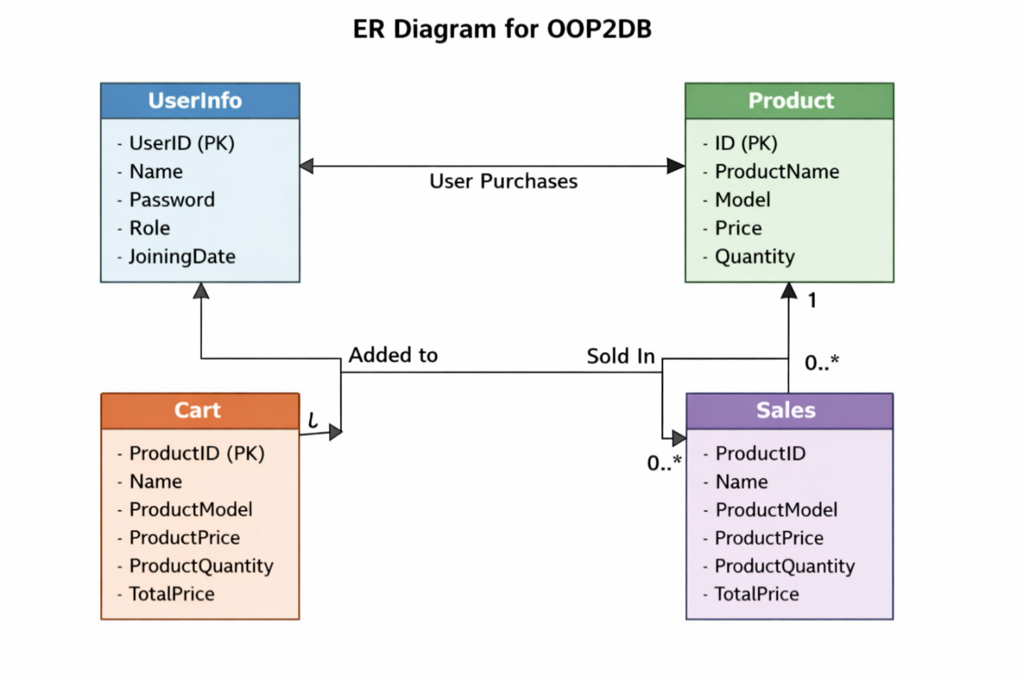

Sample Project Screenshots:

